Using C and C++ in jGrasp at Home and School
- (Home only) Install a C/C++ compiler. We recommend MinGW, which can be found at http://sourceforge.net/projects/mingw/ and is installed on the school machines.
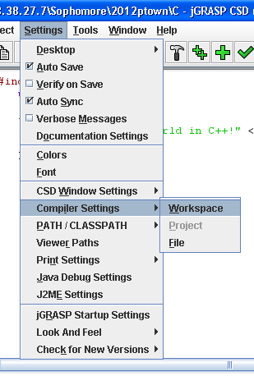
- Open jGrasp. If you don’t have JGrasp, refer to “Installing Java, jGrasp, and JKarel at Home.” Go to Settings | Compiler Settings | Workspace as shown.
- From the Language menu, select the language you will be using, in this case C++.
- In the box below, select
g++ - MinGW(C:\mingw\bin) or
gcc - MinGW(C:\mingw\bin) as
appropriate.
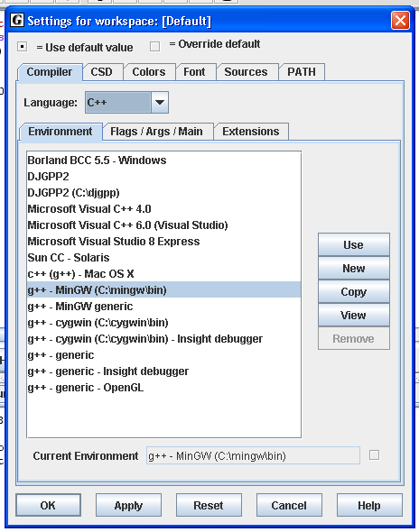
- Click Use.
- Go to Flags/Args/Main.
- Click the square next to the C/L field.
- In that field, type “-o %<base>.exe” (or .out for Linux) with no quotes.
- Click the square next to the Run field.
- In that field, type “%<base>.exe” (or .out for Linux) with no quotes.
- Click OK.
- Ascertain that the folder you are working in contains the a.exe (Windows) or a.out (Linux) file you received from your teacher.
Buttons:
Compile and Link: Creates an executable. Cannot be used to link multiple files.
Run.
